**Name:-** Dishant Modh

**Roll No:-** IT076

**EXPERIMENT 7**

**Aim:** Inter process communication (POSIX-IPC) using shared memory

Study system calls: mmap(), shm_open(), shm_unlink()

**Problem 1.** Write a program, in which one process will write message in shared memory and another process will read that message from shared memory.

**2.** Establish Inter process communication using shared memory Implement day time server and test it using client program. Tools: Linux OS, gcc compiler.

**1. Write a program, in which one process will write message in shared memory and another process will read that message from shared memory.**

**Src1.c**

**#include <stdio.h>**

**#include <fcntl.h>**

**#include <unistd.h>**

**#include <sys/stat.h>**

**#include <sys/types.h>**

**#include <sys/mman.h>**

***int* main()**

**{**

***int* size = 4096;**

**const *char* *name = "myMemory";**

***void* *ptr;**

***int* shm_fd = shm_open(name, O_CREAT | O_RDWR, 0777);**

**ftruncate(shm_fd, size);**

**printf("Starting writing in memory...\n");**

**ptr = mmap(NULL, size, PROT_WRITE, MAP_SHARED, shm_fd, 0);**

**sprintf(ptr, "%s", "Hello this is shared memory data.");**

**printf("\tWritten data : Hello this is shared memory data.\n");**

**printf("Completing writing in memory...\n");**

**return 0;**

**}**

**Dest.c**

**#include <stdio.h>**

**#include <fcntl.h>**

**#include <unistd.h>**

**#include <sys/stat.h>**

**#include <sys/types.h>**

**#include <sys/mman.h>**

***int* main()**

**{**

***int* size = 4096;**

***void* *ptr;**

***int* shm_fd = shm_open("myMemory", O_RDONLY, 0666);**

**ftruncate(shm_fd, size);**

**printf("Starting reading in shared momory...\n");**

**ptr = mmap(NULL, size, PROT_READ, MAP_SHARED, shm_fd, 0);**

**printf("\tCollected data : %s\n", (*char* *)ptr);**

**printf("completing reading in shared momory...\n");**

**shm_unlink("myMemory");**

**printf("Shared memory removed.\n");**

**return 0;**

**}**

**Output:-**

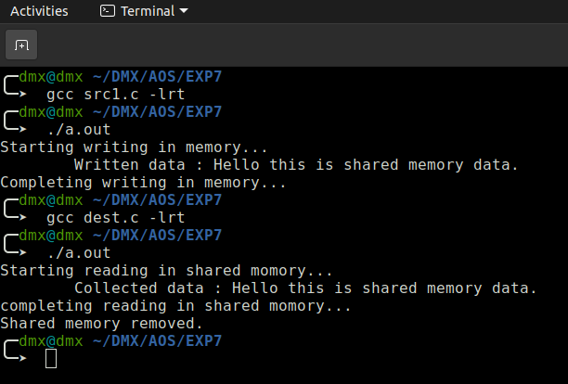

**2. Establish Inter process communication using shared memory Implement day time server and test it using client program.**

**Server.c**

**#include<stdio.h>**

**#include<fcntl.h>**

**#include<unistd.h>**

**#include<sys/stat.h>**

**#include<sys/types.h>**

**#include<sys/mman.h>**

**#include<time.h>**

**#include<pthread.h>**

***int* size=4096, shm_fd;**

***void* *ptask(*void* \**ptr*)**

**{**

**time_t now;**

***ptr* = mmap(NULL, size, PROT_WRITE, MAP_SHARED, shm_fd, 0);**

**while(1)**

**{**

**time(&now);**

**sprintf(*ptr*, "%s", ctime(&now));**

**printf("\tCurrent time in Sever : %s", ctime(&now));**

**sleep(1);**

**}**

**return NULL;**

**}**

***int* main()**

**{**

**const *char* *name = "currentTime";**

**shm_fd = shm_open(name, O_CREAT|O_RDWR, 0777);**

**ftruncate(shm_fd, size);**

**printf("Shared memory created.\n");**

**printf("To stop server hit enter.\n");**

**pthread_t threadid;**

**pthread_create(&threadid, NULL, ptask, NULL);**

**getchar();**

**pthread_cancel(threadid);**

**shm_unlink(name);**

**printf("Shared memory removed.\n");**

**return 0;**

**Client.c**

**#include<stdio.h>**

**#include<fcntl.h>**

**#include<unistd.h>**

**#include<sys/stat.h>**

**#include<sys/types.h>**

**#include<sys/mman.h>**

***int* main()**

**{**

***int* size = 4096;**

***void* *ptr;**

***int* shm_fd = shm_open("currentTime", O_RDONLY, 0666);**

**ftruncate(shm_fd, size);**

**printf("Starting reading in shared momory...\n");**

**ptr = mmap(NULL, size, PROT_READ, MAP_SHARED, shm_fd, 0);**

**printf("\tCurrent time received by Client : %s", (*char*\*)ptr);**

**printf("completing reading in shared momory...\n");**

**return 0;**

**}**

**Output:-**

